***Task 3: Visualization using Histogram***

*Create a Histogram or bar chart to visualize the distribution of a data in a datasets of column Age*

1. *Select Column Age.*
2. *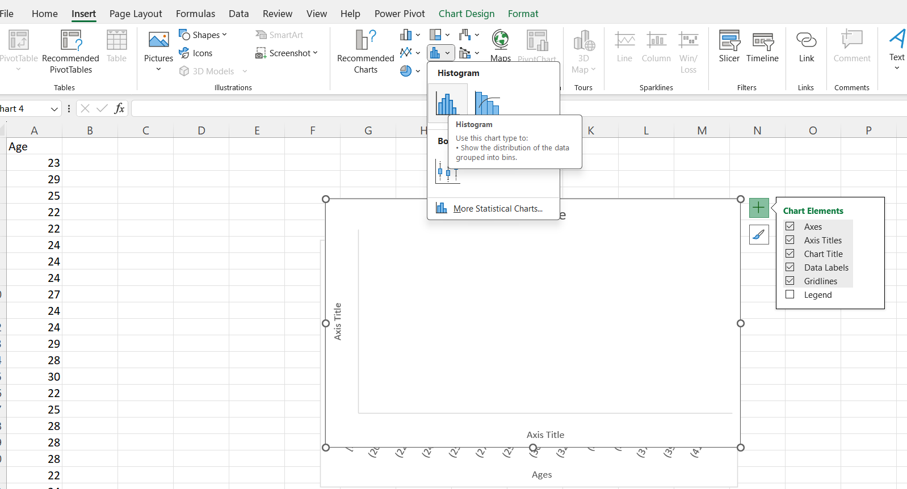Go to insert in chart group, select histogram.*

*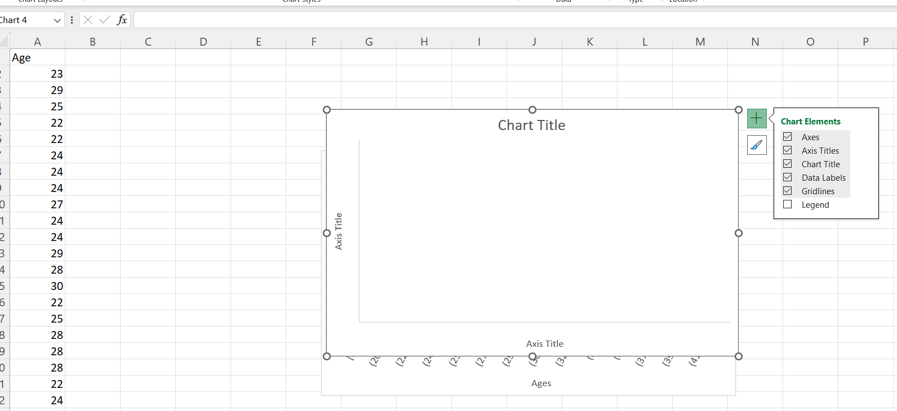 Here is Age Column. Through which we have to create histogram and visualize this age dataset.*

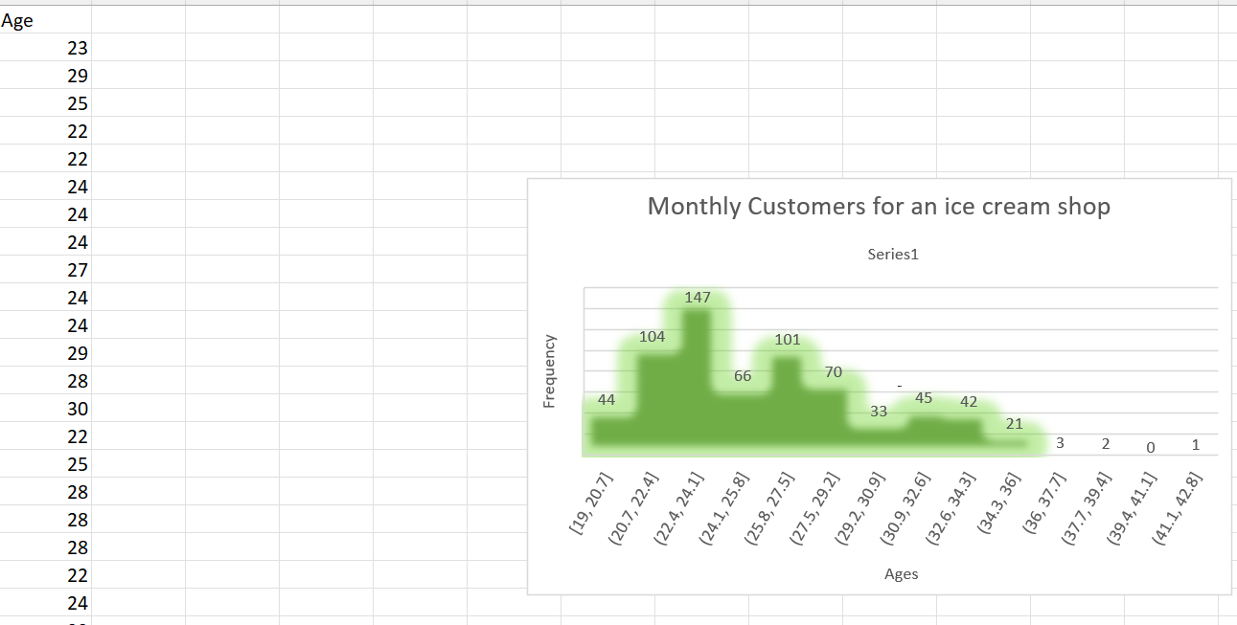

***Shaikh Jasmin Kauser***